Hudson Furnishing

**Submitted To:**

[eprojects@aptech.ac.in](mailto:eprojects@aptech.ac.in)

**Project Instructor**

Miss Ansa Tariq

**Curriculum Code**

**OV-ACCP Prime-7062-ACE**

**Group Members:**

**Arisha: student1478784**

**Abd-ur-Rahman: student1470730**

**Mehmoona: student1478720**

**Rabiya Jameel: student1478725**

We express our gratitude to the Almighty, ALLAH, for His grace that has bestowed success upon us. We are pleased to present our project on Visual Studio, designed to be in your hands. Our utmost effort has been devoted to incorporating all relevant and important topics into this project, aiming to make it comprehensive.

This project serves as our First Year Semester E-project, wherein we have strived to achieve an appealing and polished final outcome. It has been developed using Visual Studio Code, as we found this platform conducive for coding. Our chosen project revolves around creating a webpage highlighting the captivating Hudson furnishing.

We sincerely hope that this project offers all the necessary information required for users to find inspiration and fulfill their needs. However, we warmly welcome and appreciate any suggestions for improving our project

Thanks

# ACKNOWLEDGEMENT

**PROJECT CERTIFICATE**

**It is to certify that,**

**Mehmoona, Rabiya Jameel, Arisha, Abd-ur-Rahman Has Successfully Designed and Developed “Hudson Furnishing” Website.**

**Hudson Furnishing**

**Date of Issue:**

**24-june-2023**

**Authorized Signature:**

**Miss Ansa Tariq**

# INTRODUCTION TO BEAUTY OF BEACHES

Other Requirements:

* Operating Portal: Windows

Browsers: Edge, Chrome, Mozilla

* Firefox, Safari

**Software**

Technologies to be used:

Frontend: HTML5, CSS, Bootstrap, JavaScript, jQuery, AngularJS, XML

* Data Store: JSON files or TXT files

**Hardware**

* Intel Core i3/i5 Processor or higher
* 8 GB RAM or above
* Color SVGA
* 500 GB Hard Disk space
* Mouse Keyboard

**Hudson Furnishings** is a furniture shop that specializes in all home furniture needs. We are a furniture shop, a bedroom furniture store, a sofa store, a mattress shop, and a kitchen furniture store, with an emphasis on interior design. We are the only Palliser custom order studio, which offers more than 300 different fabrics or leathers to meet all your furniture needs.

In our store we make it easy for you to shop for your personal style by providing you an easy way to navigate our showrooms where you will find everything you need to decorate & organize your home. Inside our space, you'll find designer furniture that's made with heartfelt passion, as well as immaculate attention to detail.

Our goal is to take off some of the stress that comes with overwhelming amount of furniture in the market to provide you with a pleasant shopping experience.

We intend to provide you with collections of ideas to décor your home to facilitate complimenting every piece of furniture you have in your home.

We’re here to help everyone, anywhere turn their house into a home.

# DEVELOPER GUIDE

# SYSTEM REQUIREMENTS

|  |  |  |
| --- | --- | --- |
| **S.NO** | **ITEMS** | **DESCRIPTION** |
| 1 | Operating  System | Window 98 to Win 8 |
| 2 | Main processor | Minimum 366 or better |
| 3 | Ram (Memory) | Minimum 2 or better |
| 4 | Web Browser | Google Chrome |
| 5 | Software | Visual studio/JavaScript/HTML Editor/Plugins, BootSteping |

# MAP TO THE SITE

**Hudson**

**Furnishing**

Office Furniture

Home Decor

Living room

Dining room

Bed room

Home

Home Page

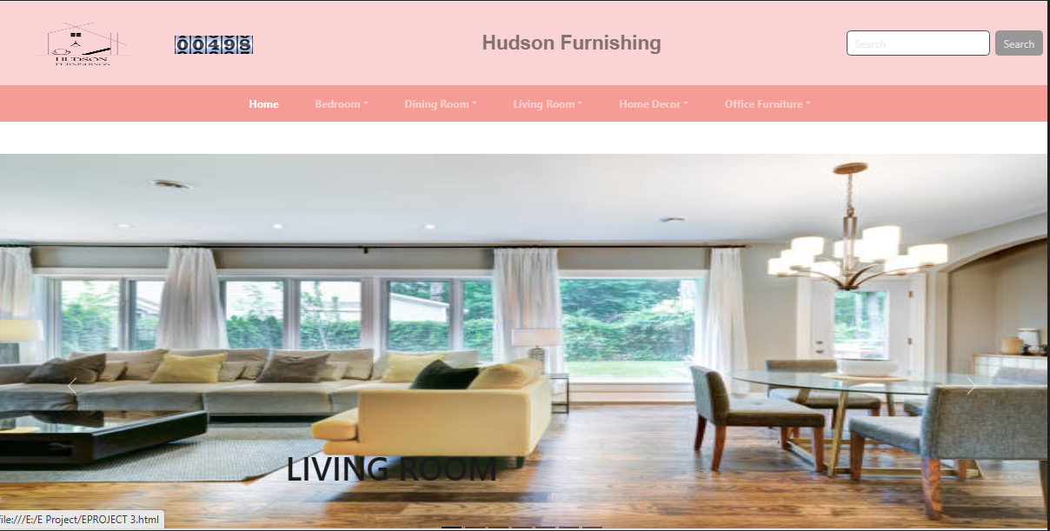

<nav class="navbar navbar-expand-lg navbar-dark " style="background: #f59c96;">

<div class="container">

<button class="navbar-toggler" type="button" data-bs-toggle="collapse" data-bs-target="#navbarNavDropdown" aria-controls="navbarNavDropdown" aria-expanded="false" aria-label="Toggle navigation">

<span class="navbar-toggler-icon"></span>

</button>

<div class="collapse navbar-collapse" id="navbarNavDropdown">

<ul class="navbar-nav">

<li class="nav-item">

<a class="nav-link active" aria-current="page" href="#home">Home</a>

</li>

<li class="nav-item dropdown">

<a class="nav-link dropdown-toggle" href="#" role="button" data-bs-toggle="dropdown">Bedroom</a>

<ul class="dropdown-menu">

<li><a class="dropdown-item" href="#modern beds">Luxury Bed Sets</a></li>

<li><a class="dropdown-item" href="#modern beds">Modern Bed Sets</a></li>

<li><a class="dropdown-item" href="#modern beds">Polish Bed Sets</a></li>

</ul>

</li>

<li class="nav-item dropdown">

<a class="nav-link dropdown-toggle" href="#" role="button" data-bs-toggle="dropdown"> Dining Room</a>

<ul class="dropdown-menu">

<li><a class="dropdown-item" href="#DINING AREa">Dining Table Set</a></li>

<li><a class="dropdown-item" href="#DINING AREA">Table Mats</a></li>

</ul>

</li>

<li class="nav-item dropdown">

<a class="nav-link dropdown-toggle" href="#" role="button" data-bs-toggle="dropdown">Living Room</a>

<ul class="dropdown-menu">

<li><a class="dropdown-item" href="#LIVING AREA">Sofas</a></li>

<li><a class="dropdown-item" href="#LIVING AREA">Recliner Sofas</a></li>

<li><a class="dropdown-item" href="#LIVING AREA">Tv Stands</a></li>

</ul>

</li>

<li class="nav-item dropdown">

<a class="nav-link dropdown-toggle" href="#" role="button" data-bs-toggle="dropdown">Home Decor</a>

<ul class="dropdown-menu">

<li><a class="dropdown-item" href="#thumb-gallery">Lamps</a></li>

<li><a class="dropdown-item" href="#thumb-gallery">Candles</a></li>

<li><a class="dropdown-item" href="#thumb-gallery">Mirrors</a></li>

<li><a class="dropdown-item" href="#thumb-gallery">Cushions</a></li>

</ul>

</li>

<li class="nav-item dropdown">

<a class="nav-link dropdown-toggle" href="#" role="button" data-bs-toggle="dropdown">Office Furniture</a>

<ul class="dropdown-menu">

<li><a class="dropdown-item" href="#">Office Chairs</a></li>

</ul>

</li>

</ul>

</div>

<a class="navbar-brand" href="">

<img src="WhatsApp_-removebg-preview.png" alt="Logo" width="40" height="30" class="d-inline-block align-text-top">

</a>

</div>

</nav>

Slider

<div class="carousel-inner" >

<div class="carousel-inner">

<div class="carousel-item active">

<img src="living room3.jpg" class="d-block" style="width: 100%; height: 600px; margin-top: 50px;">

<div class="carousel-caption d-none d-md-block">

<h2 style="font-family: 'Segoe UI', sans-serif; color: rgb (27, 25, 25); margin-bottom: 50px; margin-left: -400px; font-size: 50px;">LIVING ROOM</h2>

</div></div>

<div class="carousel-inner">

<div class="carousel-item ">

<img src="luxury bed.jpg" class="d-block" style="width: 100%; height: 600px; margin-top: 50px;">

<div class="carousel-caption d-none d-md-block">

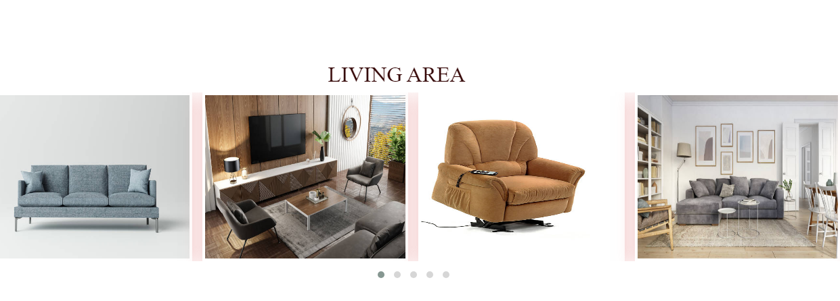

<h2 style="font-family: 'Segoe UI', sans-serif; color: rgb (27, 25, 25); margin-bottom: 50px; margin-left: -500px; font-size: 50px;">LUXURY BED ROOM</h2>

</div>

</div>

<div class="carousel-item ">

<img src="living room.jpg" class="d-block" style="width: 100%; height: 600px; margin-top: 50px;">

<div class="carousel-caption d-none d-md-block">

<h2 style="font-family: 'Segoe UI', sans-serif; color: rgb (27, 25, 25); margin-bottom: 50px; margin-left: -500px; font-size: 50px;">SOFA SETS</h2>

</div>

</div>

<div class="carousel-item ">

<img src="kitc4.jpg" class="d-block" style="width: 100%; height: 600px; margin-top: 50px;">

<div class="carousel-caption d-none d-md-block">

<h2 style="font-family: 'Segoe UI', sans-serif; color: rgb (27, 25, 25); margin-bottom: 50px; margin-left: -500px; font-size: 50px;">KITCHEN</h2>

</div>

</div>

<div class="carousel-item ">

<img src="sofa set.jpg" class="d-block" style="width: 100%; height: 600px; margin-top: 50px;">

<div class="carousel-caption d-none d-md-block">

<h2 style="font-family: 'Segoe UI', sans-serif; color: rgb (27, 25, 25); margin-bottom: 50px; margin-left: -500px; font-size: 50px;">SOFA SETS</h2>

</div>

</div>

<div class="carousel-item ">

<img src="d-table1.jpg" class="d-block" style="width: 100%; height: 600px; margin-top: 50px;">

<div class="carousel-caption d-none d-md-block">

<h2 style="font-family: 'Segoe UI', sans-serif; color: rgb(27, 25, 25); margin-bottom: 50px; margin-left: -500px; font-size: 50px; ">DINING TABLE</h2>

</div>

</div>

<div class="carousel-item ">

<img src="bed23.jpg" class="d-block" style="width: 100%; height: 600px; margin-top: 50px;">

<div class="carousel-caption d-none d-md-block">

<h2 style="font-family: 'Segoe UI', sans-serif; color: rgb (27, 25, 25); margin-bottom: 50px; margin-left: -500px; font-size: 50px;">BED SETS</h2>

</div>

</div>

</div></div>

Top Trending

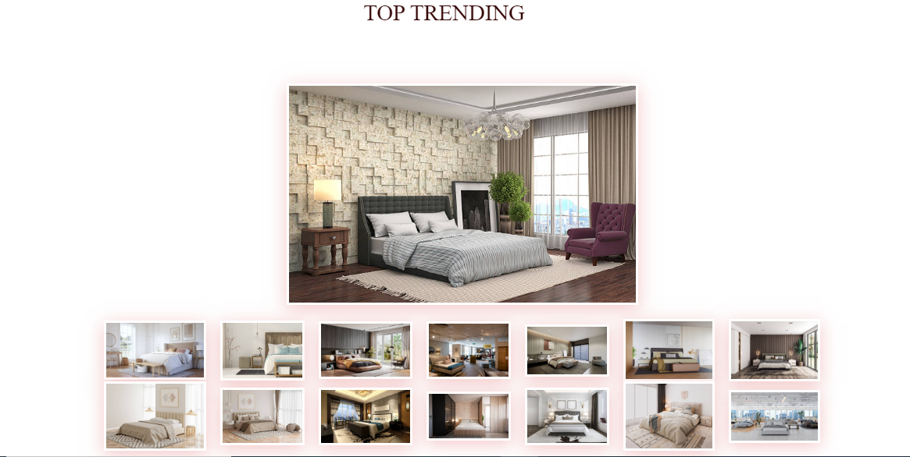]

<h2 style="font-family: 'Times New Roman', Times, serif; color: rgb(52, 5, 5); margin-left: 40%; justify-content: center;"

data-aos="zoom-in">TOP TRENDING</h2>

<br>

<div class="imgBox"><img src="bed25.jpg"></div>

<ul class="thumb" data-target="p-1">

<li><a href="bed1.jpg" target="imgBox" width="400px"><img src="bed1.jpg" width="145px"></a></li>

<li><a href="bed2.jpg" target="imgBox" width="400px"><img src="bed2.jpg" width="120px"></a></li>

<img src="bed2.jpg" width="120px"></a></li>

<li><a href="bed3.jpg" target="imgBox" width="400px"><img src="bed3.jpg" width="133px"></a></li>

<li><a href="bed15.jpg" target="imgBox" width="400px"><img src="bed15.jpg" width="120px"></a></li>

<li><a href="bed16.jpg" target="imgBox" width="400px"><img src="bed16.jpg" width="120px"></a></li>

<li><a href="bed13.jpg" target="imgBox" width="400px"><img src="bed13.jpg" width="130px"></a></li>

<li><a href="bed6.jpg" target="imgBox" width="400px"><img src="bed6.jpg" width="130px"></a></li>

</ul>

<ul class="thumb">

<li><a href="bed7.jpg" target="imgBox" width="400px"><img src="bed7.jpg" width="145px"></a></li>

<li><a href="bed8.jpg" target="imgBox" width="400px"><img src="bed8.jpg" width="120px"></a></li>

<li><a href="bed9.jpg" target="imgBox" width="400px"><img src="bed9.jpg" width="133px"></a></li>

<li><a href="bed10.jpg" target="imgBox" width="400px"><img src="bed10.jpg" width="120px"></a></li>

<li><a href="bed11.jpg" target="imgBox" width="400px"><img src="bed11.jpg" width="120px"></a></li>

<li><a href="bed12.jpg" target="imgBox" width="400px"><img src="bed12.jpg" width="130px"></a></li>

<li><a href="bed114.jpg" target="imgBox" width="400px"><img src="bed14.jpg" width="130px"></a></li>

</ul>

Gallery

<br>

<div class="gallery" data-aos="zoom-in-up">

<ul class="controls" data-aos="zoom-in-up">

<li class="buttons" data-filter="all">All</li>

<li class="buttons" data-filter="lamps">Lamps</li>

<li class="buttons" data-filter="Cushions">Cushions</li>

<li class="buttons" data-filter="Candles">Candles</li>

<li class="buttons" data-filter="mirrors">Mirrors</li>

<div class="image-container">

<a href="lamp10.jpg" class="image lamps">

<img src="lamp10.jpg">

</a>

<a href="lamp3.jpg" class="image lamps">

<img src="lamp3.jpg">

</a>

<a href="lamp14.jpg" class="image lamps" >

<img src="lamp14.jpg">

</a>

<a href="lamp5.jpg" class="image lamps">

<img src="lamp5.jpg">

</a>

<a href="cushion7.jpg" class="image Cushions">

<img src="cushion7.jpg">

</a>

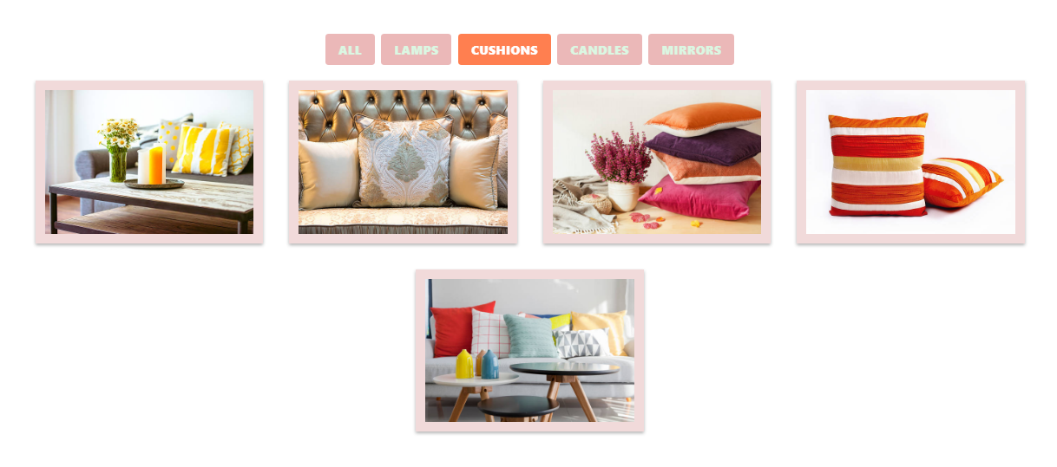

<a href="cushion9.jpg" class="image Cushions">

<img src="cushion9.jpg">

</a>

<a href="cushion4.jpg" class="image Cushions">

<img src="cushion4.jpg">

</a>

<a href="cushion5.jpg" class="image Cushions">

<img src="cushion5.jpg">

</a>

<a href="cushion6.jpg" class="image Cushions">

<img src="cushion6.jpg">

</a>

<a href="mirror11.jpg" class="image mirrors">

<img src="mirror11.jpg">

</a>

<a href="mirror2.jpg" class="image mirrors">

<img src="mirror2.jpg">

</a>

<a href="mirror3.jpg" class="image mirrors">

<img src="mirror3.jpg">

</a>

<a href="candel1.jpg" class="image Candles">

<img src="candel1.jpg">

</a>

<a href="candel2.jpg" class="image Candles">

<img src="candel2.jpg">

</a>

<a href="candel4.jpg" class="image Candles">

<img src="candel4.jpg">

</a>

<a href="candel5.jpg" class="image candles">

<img src="candel5.jpg">

</a>

<a href="mirror8.jpg" class="image mirrors">

<img src="mirror8.jpg">

</a>

<a href="mirror 1.jpg" class="image mirrors">

<img src="mirror 1.jpg">

</a>

</div>

</div>

New Arrivals

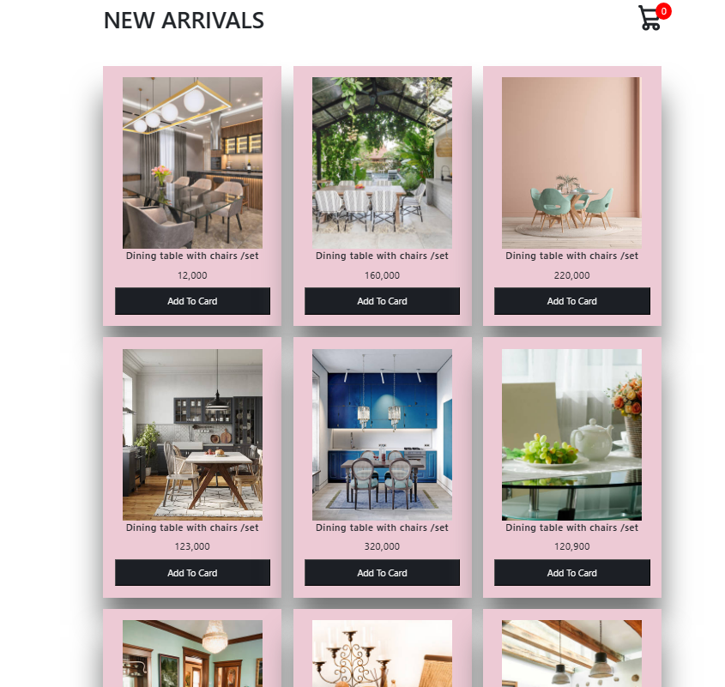

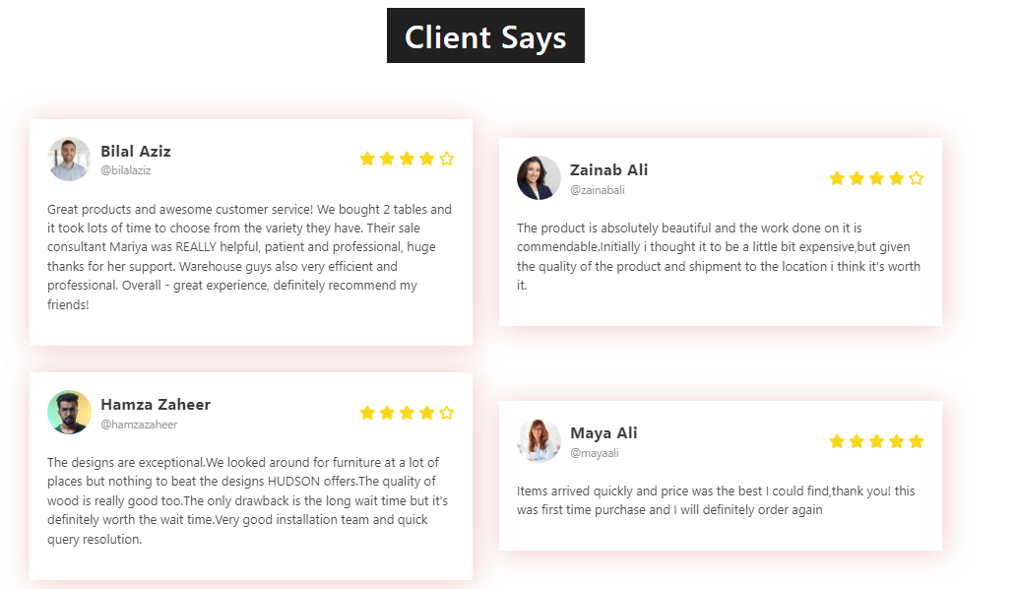

Client Review

Our Location

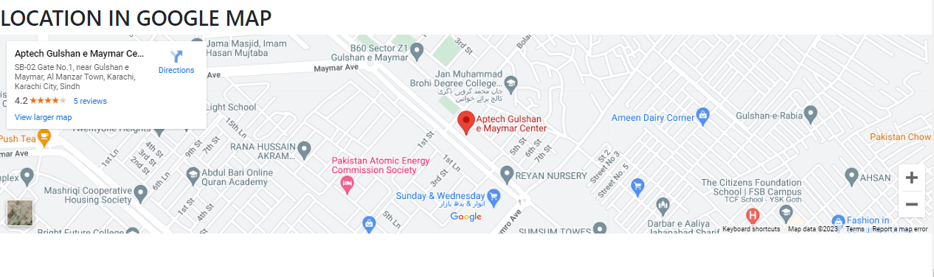

**Our Location on Google Map**

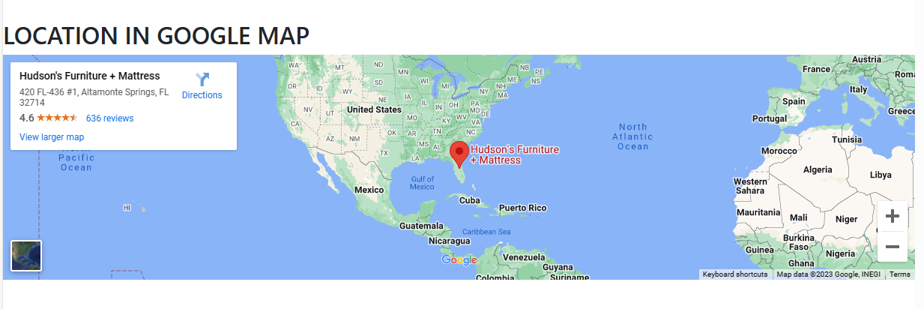

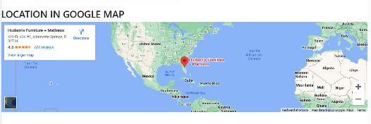

**Our Location on Google Map**

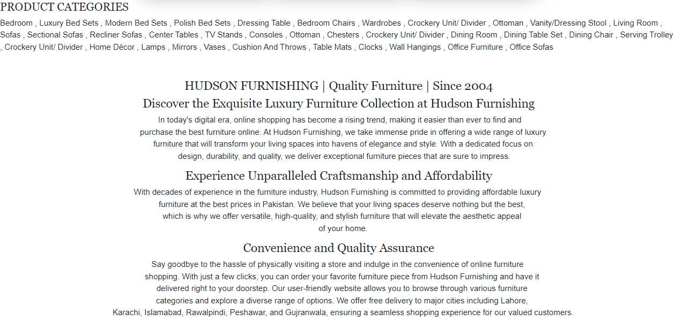

**Contact Us**

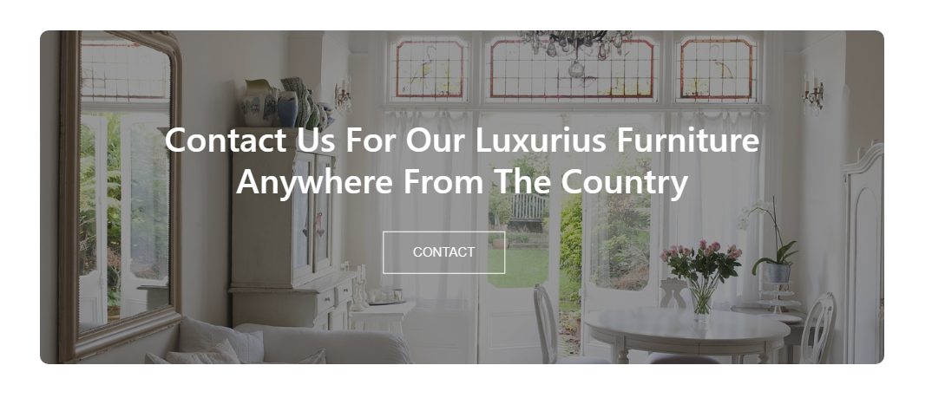

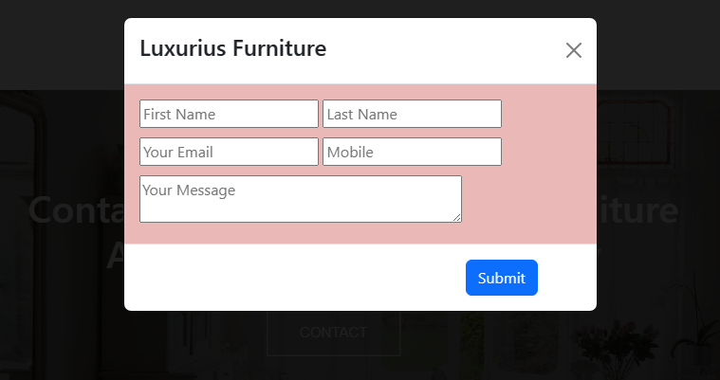

**About Us**

